:
Memorandum

To: All DCF Staff

From: Commissioner Vannessa Dorantes

Date: 7/5/2020

Re: Weekly Update & Commissioner video
______________________________________________________________________________

Happy 4th of July to everyone!
As always, THANK YOU to our 24/7 staff at the SOLNITs and CARELINE for holding it down so the rest of us could have an extra day off!

Click here => Commissioner's Weekly Video 7-5-20 to hear more on this week's three key areas of …

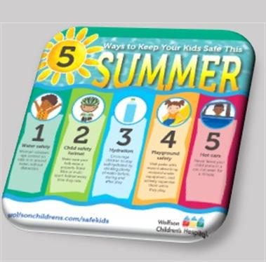

IN CHILDREN'S SUMMER SAFETY-- Even with different types of holiday weekend observances, as usual for this time of year, the Department has been receiving reports of critical injuries of children.

Please take this opportunity to review some basic summer safety tips with parents:

  - SUPERVISE ON PURPOSE
    - Put the cell phones down & be present
  - Watch little ones around windows, decks and porches
( kids love to wave, climb & lean over!)
    - ensure screens are secure
    - move furniture away from window ledges and porch railings
  - WATER IS REFRESHING & CAN BE DANGEROUS
    - Identify a #WaterWatcher https://ymcanyc.org/programs/swimming-ymca/water-watcher
    - Stay attentive & within arm's-length of children while bathing, in a pool and around ANY body of water
    - Encourage swimming lessons

  - Check the backseat before leaving the car!!!
            - Temperatures climb really high REALLY FAST
            - Put something ( your shoe, phone or purse in the back as a reminder)
            - Lock cars when not in use; children can climb inside to play

  - Other HEAT SOURCES pose hazards too…
          - Do not let children play with fireworks - even sparklers
          - Watch children closely around stoves, grills, campfires/open flames and hot substances. Burns happen quickly and can be severe!!!

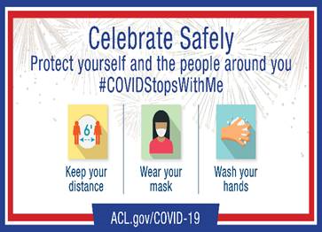IN COVID - 19 TRANSMISSION PROTECTION--
In keeping with our theme, remain vigilant against the spread of COVID-19.
- As more activities are taking place in our communities, and as the Department is conducting more in-person visits, basic precautions must continue.
- Connecticut has done an excellent job addressing containing the effects of the Coronavirus.
- Maintain social distancing, wear a mask, wash your hands and address any health issues you may have immediately.
IN ANTI-RACIST SYSTEM TRANSFORMATION--
CT DCF has been a vigilant, national leader in racial justice
https://myemail.constantcontact.com/Racial-Equity-Resources-from-NCWWI.html?soid=1103622714543&aid=tzxEQIWtBj0
If this is the case…. Why isn’t the 'needle' moving on our 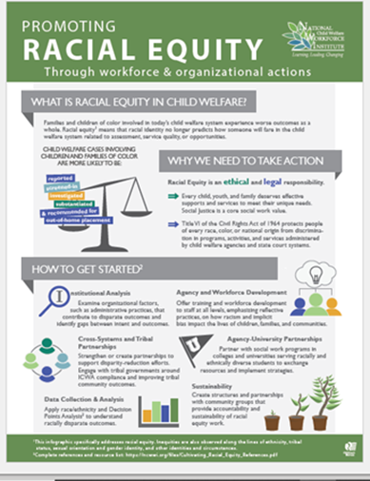outcomes?

- CT DCF's evolution is in the midst of a societal revolution.
      - People of Color are overrepresented in the child welfare system…
            - We are also hurting, tired & filled with lots of other emotions.
- To understand WHY, we ALL need to do our own "work" personally.
- American history is interpreted through the lens by which we are taught and experience it as it unfolds.
- Cultural humility is the constant openness to learn, adapt and change in the context of the world around us
- CT DCF system work, at the institutional level, compels us to assess and adjust our policy, practice and data when they don’t match our values.

As another means of enhancing communication, the newly established DCF.RacialJustice@ct.gov mailbox has been created to offer you a place to share information, pose questions and offer suggestion on how to enhance and improve policies, practices & workplace norms within CT DCF. Suggestions posed will be reviewed timely & may be presented at the Statewide Racial Justice Workgroup for further assessment, follow up and presentation to CT DCF leadership.
This is another purposeful step to UNDERSTAND, EMPATHIZE, and respond with AUTHENTICITY.

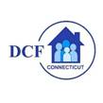VANNESSA L. DORANTES, LMSW
COMMISSIONER
CT DEPT OF CHILDREN & FAMILIES
505 HUDSON STREET
HARTFORD, CT 06106

commissioner.dcf@ct.gov (860)550-6300
" I do my best because I'm counting on YOU counting on me…"
m angelou

